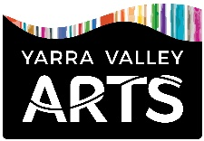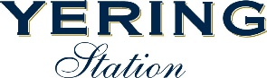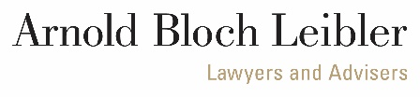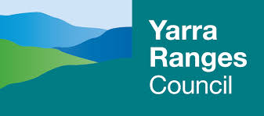

YARRA VALLEY ARTS | YERING STATION SCULPTURE EXHIBITION & AWARDS 2023
INTRODUCTION

The Yarra Valley Arts | Yering Station Sculpture Exhibition & Awards is a collaborative event hosted by Yering Station, a premier winery in the Yarra Valley region of Victoria with an arts program encompassing painting, photography and sculpture, and Yarra Valley Arts, a not-for-profit organisation dedicated to enhancing the cultural lives of Yarra Valley residents and visitors.

The exhibition presents new Australian sculpture, in all mediums, by emerging, mid-career and established artists. Having grown steadily since 2001, it is now the longest running annual sculpture exhibition in Victoria and an iconic event on the Australian arts calendar.

Staged across dramatic landscaped gardens designed by Michael McCoy, the exhibition provides ample opportunities for the installation of outdoor sculpture, while the long indoor corridors and breezeways offer indoor and sheltered spaces. Finalists are encouraged to visit the property and to select a site which best suits their work.

The exhibition at Yering Station runs alongside a concurrent exhibition of sculpture staged through the Collins Street offices of long-standing sponsor Arnold Bloch Leibler. In addition, a small sculpture exhibition is hosted by Yarra Valley Arts at YAVA Gallery & Arts Hub in Healesville, and all entrants are invited to submit a small sculpture for consideration.

Dr Ewen Jarvis (Exhibition Coordinator and Curator, Yering Station Art Gallery and Yarra Valley Arts | Yering Station Sculpture Exhibition & Awards) is a professional art curator, writer and public academic with over a decade of public art presentation and arts administration experience.

The event takes a 30% commission on sculpture sales, 20% of which is donated to My Room Children’s Cancer Charity, while 10% is donated to Yarra Valley Arts towards the provision and promotion of arts events across the region.

The sculpture exhibition is supported by long term sponsors who share the vision and aims of the organisers — to foster the development and public appreciation of contemporary Australian sculpture. Arnold Bloch Leibler – lawyers and advisers, Yarra Ranges Council and RACV have been particularly strong supporters across the years. The event is also supported by a growing number of esteemed arts professionals who have been members of the selection and judging panel in the past and who assists us in growing the event’s profile.

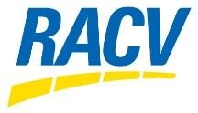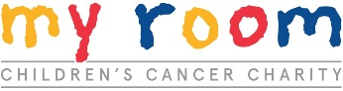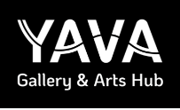

YARRA VALLEY ARTS | YERING STATION SCULPTURE EXHIBITION & AWARDS 2021
Conditions of Entry

SELECTION and judging panel PRIZES and AWARDS (NON-ACQUISITIVE)

Dr Simon Perry Yering Station Sculpture Award $12,000
Penny Teale Arnold Bloch Leibler Sculpture Award $5,000
Awaiting details of third exhibition judge RACV Sculpture Award $1,000
Yering Station Art Gallery Award
People’s Choice Sculpture Award
Winery Choice Award

GENERAL INFORMATION

- The event at Yering Station is an exhibition of indoor and outdoor sculpture with scope for installations and site-specific works.
- Indoor works must be free standing, with plinth/s supplied by the artist (all plinths must be in good order and freshly painted).
- We are unable to attach works to the walls, but we are able, in some places, to suspend works from the ceiling.
- There is a two entry limit per sculptor, and late entries will not be accepted.
- Exhibits must remain on display for the duration of the exhibition.
- The artist agrees to images, extracts from artist statements and CVs being used for exhibition publicity purposes.
- The awards and prize money may change subject to funding and sponsorship arrangements.

SELECTION

- Entries close Monday 3 July 2023.
- The selection panel will determine successful entries, and all artists will be notified by Friday 4 August.
- The decision of the selection panel will be final with no further correspondence entered into.
- After selection, all entrants will be invited to submit a small sculpture to be considered for inclusion in the YAVA Small Sculpture Exhibition.
- All work must be original and available for sale.
- The committee reserves the right to withdraw or relocate any entry deemed unsuitable or dangerous to the public, prior to and during the exhibition, after consultation with the artist. Finalists will be required to sign a conditions and terms of agreement form.
- CVs, photographs, jpeg image files, and an installation safety plan must be included with the Entry Form. Works currently in progress are acceptable for consideration with support material.
- The artist’s statement (50 words maximum) is to be included with the Entry Form. This will appear in the catalogue.
- An application and selection process will determine artist participation in the concurrent Small Sculpture Exhibition at YAVA Gallery and Arts Hub. The terms and conditions of this exhibition will be included with an invitation to apply subsequent to the selection process for the Yering Station exhibition.

INSTALLATION & DELIVERY

- Sculptors will take responsibility for the installation and public safety of their work. Finalists are welcome to book an appointment to discuss placement and installation.
- The artist is also responsible for delivery, installation costs, any associated insurance costs, and the provision of a plinth if required (plinths must be freshly painted and in good condition).
- On delivery each exhibit must be clearly labeled with sculptor’s name, sculpture title, medium, dimensions, sculptor’s mobile and sale price.

IMPORTANT DATES

- The exhibition will show from Sun 22 Oct – Sun 3 Dec 2023
- Opening and Awards Presentation 1.00 PM Sun 22 Oct in Yering Station’s historic barn
- Installation dates will be strictly 9.00 am – 5.00 pm Mon 2 Oct, Tues 3 Oct, Wed 4 Oct
- Deinstallation dates will be strictly 9.00 am – 5.00 pm Monday 4 Dec, Tuesday 5 Dec

FEES

- A non-refundable administrative entry fee of $45 PER ENTRY is required (transfer funds directly to The Yarra Valley Arts Council Inc. BSB 633 000 Acc. No. 164 397 242. Please submit with reference YSSA Surname Initial, e.g., YSSA Smith A)
- A commission of 30% will be charged on all works sold (20% is donated to My Room Children’s Cancer Charity, while the remaining 10% is forwarded to Yarra Valley Arts to promote and support arts events in the region).
- The sale price on the confirmation form will be the catalogue price, so ensure the 30% commission is included. The organising committee will not be held responsible for any discrepancies.

SECURITY

- There is a security patrol at Yering Station twice nightly, however the exhibition organisers hold no insurance against damage or burglary of works. Public Liability insurance is covered by the exhibition.
- The exhibition does not have an accidental / malicious damage insurance policy and artists are advised to individually insure their works against damage and theft. This is not a traditional gallery situation, and although we do our best to safeguard artworks some people will invariably touch. Please speak with the curator if you have any installation queries.

DEINSTALLATION & CONCLUSION OF EXHIBITION

- If the artist wishes an agent to collect their work, authorisation must be in writing to the curator.
- Artists will be responsible for the delivery of sold artwork to a radius of 100km from Yering Station or by arrangement with the purchaser.
- Payment by electronic funds transfer for sale of exhibits will occur within six weeks of the art buyer’s final payment.

YARRA VALLEY ARTS / YERING STATION SCULPTURE EXHIBITION & AWARDS 2021
ENTRY FORM

NAME ______________________________________________
ADDRESS ______________________________________________
________________________________________ POST CODE ______________
EMAIL ________________________________________

PHONE ________________________________________

MOBILE ________________________________________
SCULPTURE TITLE ____________________________________________________________________
MEDIUM ________________________________________
DIMENSIONS __________________________ INDOOR OR OUTDOOR _______________
PRICE __________________________ (Include 30% commission, and GST if applicable)

Please also provide the following:

- Curriculum Vitae
- 50 word artist’s statement for the exhibition catalogue
- Clearly labelled images / drawings / photographs / jpeg images
- Installation details (approximate installation time and safety installation plan including necessary equipment and tools)
- $45 Entry Fee: please transfer funds to Yarra Valley Arts BSB 633 000 Acc.164 397 242) with reference YSSA Surname Initial, e.g., YSSA Smith A)
- Include a self-addressed stamped envelope if you require the return of submitted material

Enter by mail: Yering Station Sculpture Exhibition, PO Box 390 Yarra Glen Vic 3775

Enter by email: artgallery@yering.com

ENTRIES CLOSE Monday 3 July

If you would like to survey the exhibition spaces you are encouraged to visit the grounds of Yering Station and Chateau Yering, which are open to the public 10am - 5pm weekdays and 10am - 6pm on weekends and public holidays. For further information or to arrange an appointment please contact Dr Ewen Jarvis | Exhibition Coordinator and Curator | (03) 9730 0102 | artgallery@yering.com

